Software upgrade for smart tachographs lets bus drivers drive off in less time
- More time saved: correct, automatic recommendation in the country list and faster manual entries in multi-manning operation
- Many improvements increase user-friendliness
- The upgrade is now available for all DTCO 4.0-generation tachographs
Villingen-Schwenningen, Germany, April 21, 2021. The technology company Continental is providing an upgrade for the smart digital tachograph. The new software version 4.0e of the DTCO offers improved performance and user-friendliness, making everyday work easier for drivers.
Bus companies that upgrade their vehicles to version 4.0e of the DTCO benefit in several ways: New functions such as automatic recognition of the current country via satellite ensure even more time savings in the cockpit. The new working time counter – together with the already proven driving time counter – offers a fuller overview for the drivers. Warnings when daily or weekly working hours are exceeded are shown on the display, reducing the risk of corresponding violations and fines. The timeframe during which manual corrections and extra later entries for working times can be entered has also been significantly extended to ten minutes. This offers drivers more flexibility and helps to prevent wrong entries.
Better performance, better efficiency
In addition to the new functions, the upgrade contributes to improved overall performance of the digital tachograph. This is particularly evident in driver card handling, which has now been greatly simplified and accelerated. For example, the vehicle can now be driven away while the card is still being read in – the “ready to drive” display tells the driver when he can drive off. The waiting time until manual entries can be made is also much shorter for tachographs that have received the 4.0e update. For vehicles in multi-manning operation, the 4.0e update of the smart tachograph offers some special improvements: for example, the manual entry of the second driver can now be carried out straight after the manual entry of the first driver.
Since the DTCO 4.0 generation, the VDO tachograph can assist in the automatic adjustment of the driver’s seat and the rear and exterior mirrors for the current driver. This comfort function carries out its adjustments by reading the inserted driver card and it is being increasingly offered in new commercial vehicle models. The 4.0e upgrade has greatly accelerated the process. “We have developed the 4.0e version of the DTCO in close cooperation with drivers to better meet their needs and requirements for our digital tachograph,” says Marcello Lucarelli, Head of the Commercial Vehicle Fleet Services business segment at Continental. “The software upgrade is first and foremost a comfort feature, but it improves user-friendliness, speeds up processes and provides more transparency – so drivers and transport company managers both benefit.” Continental recommends that all fleets install the upgrade.
Simple installation in workshops
The DTCO 4.0e upgrade is available immediately for all smart tachographs of the VDO DTCO 4.0 generation. It can be carried out in workshops, for example, as part of the periodic inspection in less than ten minutes. This makes it a lot less complex than exchanging hardware. Every upgrade includes activation of the VDO Counter and, thus, the working time counter. Newly delivered tachographs are already equipped with version 4.0e ex works. Workshops that want to offer their customers the upgrade can obtain licenses from their usual sources.
Continental develops pioneering technologies and services for sustainable and connected mobility of people and their goods. Founded in 1871, the technology company offers safe, efficient, intelligent, and affordable solutions for vehicles, machines, traffic and transportation. Continental generated preliminary sales of €37.7 billion in 2020 and currently employs more than 235,000 people in 58 countries and markets. In 2021, the company celebrates its 150th anniversary.
Continental develops pioneering technologies to make commercial transport safer, more efficient and more connected. The company’s products and services deliver measurable impact for commercial vehicle manufacturers and the aftermarket. They benefit from a broad portfolio and from fully integrated systems. The portfolio includes tires, digital tire monitoring, fleet management, telematic solutions, Electronic Logging Devices (ELD) and tachographs, hoses, air springs, Electronic Control Units (ECU), displays, drivetrain and exhaust aftertreatment systems, sensors, advanced driving assistance systems, as well as eHorizon maps and events and cloud based services. In 2019, the share of Continental’s global sales for commercial vehicle products, systems and services was 5 billion.
Press contact

Oliver Heil
Manager Media Relations
Commercial Vehicles & Services
Continental Aftermarket & Services GmbH
Phone: +49 6196 87-2681
Email: oliver.heil@continental.com
Press portal: www.continental-press.com
Media center: continental.com/media-center
VDO Website: www.fleet.vdo.com
Social Media: https://www.linkedin.com/company/vdo-deutschland
https://www.facebook.com/vdode

pictures/captions
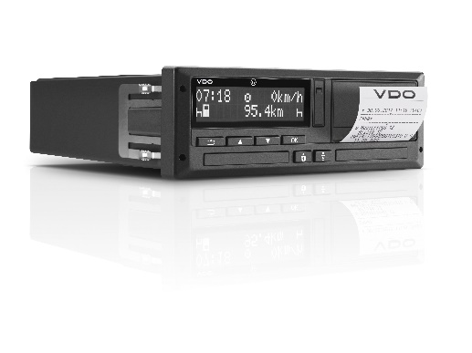  Continental_VDO_PP_DTCO4.0 | The new software update for the smart tachograph saves drivers a lot of time.
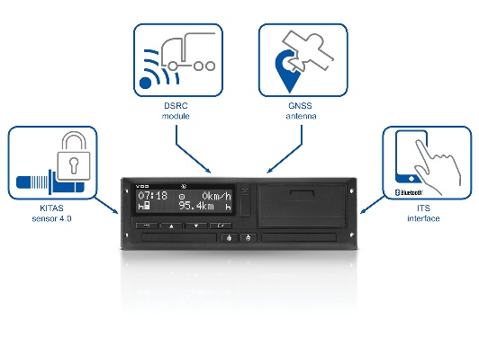  Continental_VDO_PP_DTCO4.0_  Features | New update increases user-friendliness.
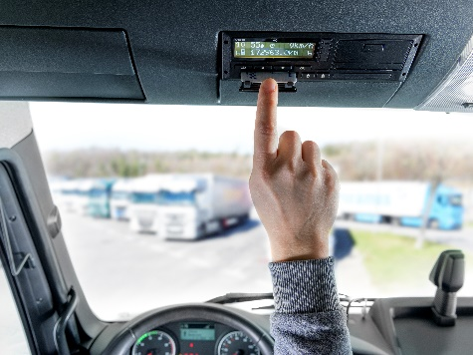  Continental_PP_VDO_DTCO_  Cockpit | Driver cards are now read much faster.
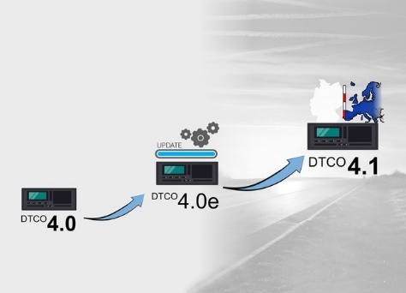 | New cross-border recognition via satellite automatically recognizes the country in which the vehicle is located.
Continetal_VDO_PP_DTCO_
Evolution

