Facelift and Upgrade: The Second-Generation VDO WorkshopTab for Tachograph Maintenance is Here
- The new tablet facilitates simple and reliable planning of service in truck workshops, ensuring continuity in inspection and calibration
- The digital helper is now better than ever: future-ready software, longer battery life, an improved display and maintenance-friendly components
- The VDO WorkshopTab 2, for comprehensive inspection and calibration in compliance with the German Road Traffic Licensing Regulations, is available now
Villingen-Schwenningen, Germany, May 12, 2022. Continental’s Workshop Tablet, an essential tool in thousands of European truck workshops, has now come out in a version with a bigger and brighter display, improved handling and updated software. In anticipation of the coming surge in orders when smart second-version tachographs become mandatory, the VDO WorkshopTab 2 offers comprehensive inspection and legally compliant calibration in accordance with Section 57b of the German Road Traffic Licensing Regulations (StVZO). The successor to the VDO WorkshopTab is available now.
The VDO WorkshopTab 2 features numerous improvements in details, but two important elements remain unchanged. First, the wizard will continue to guide users step by step through the inspection process to ensure that everything has been filled out correctly. Second, the wide range of services for the WorkshopTab will remain available. “This new generation will continue the success story of the WorkshopTab as an indispensable aid for efficient and reliable testing in accordance with the German Road Traffic Licensing Regulations,” says Marcello Lucarelli, Head of Connected Commercial Vehicle Solutions at Continental. “It will make inspections simpler, more reliable and easier to plan. In short, our customers will be ready for the future.”
Brighter display and anti-reflective coating for outdoor work
The new VDO WorkshopTab 2 immediately catches the eye with its 11.6-inch display, which is 20 percent larger than that of its predecessor. Moreover, the display is much brighter, with a luminance of 800 nits (predecessor: 350 nits). For comparison, the luminance of a typical computer monitor is 200 to 300 nits. The display also has a textured coating for glare prevention and better color rendering. These improvements are very helpful for outdoor work, for example calibration of the satellite signal to determine the exact location of a vehicle and measurement of the vehicle characteristic (w factor).
A hard rubber edge for protection and a deeper card slot
A hard rubber edge running all the way around the tablet protects it against impacts and provides a good non-slip grip. A new touch sensor in the device increases the responsiveness and sensitivity of the touchscreen, making work easier for workers with dirty hands. The card reader of the WorkshopTab 2 is also new. Workshop cards can now be inserted deeper into the slot. The cards can still be pulled out with no trouble, but they don’t protrude as much when the tablet is being used. If, however, the card slot happens to be damaged, replacement is simple because it is now a separate component.
Many years of use: no problem thanks to Windows 10 and better computer components
The WorkshopTab 2 offers better performance thanks to a new operating system: Windows Embedded 10 Enterprise with a long-term service warranty from Microsoft. It also has a faster Intel Pentium® microprocessor and increased battery capacity. The battery capacity of 5,900 milliampere hours (mAh) extends its operating time by almost 40 percent. Even when working at full load, the tablet can be used as long as 5.5 hours without need for recharging. The user interface and menu navigation remain unchanged since they were continuously updated in the first-generation tablet. “The WorkshopTab 2 ensures continuity in inspection work, and at the same time it’s ready for the future,” says Jan Engesser, product manager for the WorkshopTab. “It can be better integrated into IT architectures and has the capacity to meet future requirements for digital tachographs.”
Easy replacement
Replacing a WorkshopTab with a WorkshopTab 2 is very simple. Licenses and stored data can easily be transferred to the new device. As for other hardware, all accessories of the WorkshopTab can be used with its successor, with the exception of the docking station. Service contracts between licensed workshops and their partner dealers can also be transferred. “With this change in generations we’ve also put a strong emphasis on continuity in our customers’ processes,” says Jan Engesser. “Workshop customers and fleet customers can carry out the important Section 57b test without trouble. What’s more, the WorkshopTab 2 is more advanced, faster and easier to use.”
For information on the new VDO WorkshopTab 2 as initial equipment or as a replacement, visit www.fleet.vdo.com/products/vdo-workshoptab-2.

Continental develops pioneering technologies and services for sustainable and connected mobility of people and their goods. Founded in 1871, the technology company offers safe, efficient, intelligent and affordable solutions for vehicles, machines, traffic and transportation. In 2021, Continental generated sales of €33.8 billion and currently employs more than 190,000 people in 58 countries and markets. On October 8, 2021, the company celebrated its 150th anniversary.
Continental develops pioneering technologies to make commercial transport safer, more efficient and more connected. The company’s products and services deliver measurable impact for commercial vehicle manufacturers and the aftermarket. They benefit from a broad portfolio and from fully integrated systems. The portfolio includes tires, digital tire monitoring, fleet management, telematic solutions, Electronic Logging Devices (ELD) and tachographs, hoses, air springs, Electronic Control Units (ECU), displays, drivetrain and exhaust aftertreatment systems, sensors, advanced driving assistance systems, as well as eHorizon maps and events and cloud based services. In 2019, the share of Continental’s global sales for commercial vehicle products, systems and services was 5 billion.

Press contact

Oliver Heil
Manager Media Relations
Smart Mobility
Continental
Phone: +49 6196 87-2681
Email: oliver.heil@continental-corporation.com

Press portal: www.continental-press.com
Media center: www.continental.com/media-center
Product information: www.fleet.vdo.com/products/vdo-workshoptab-2

pictures/captions
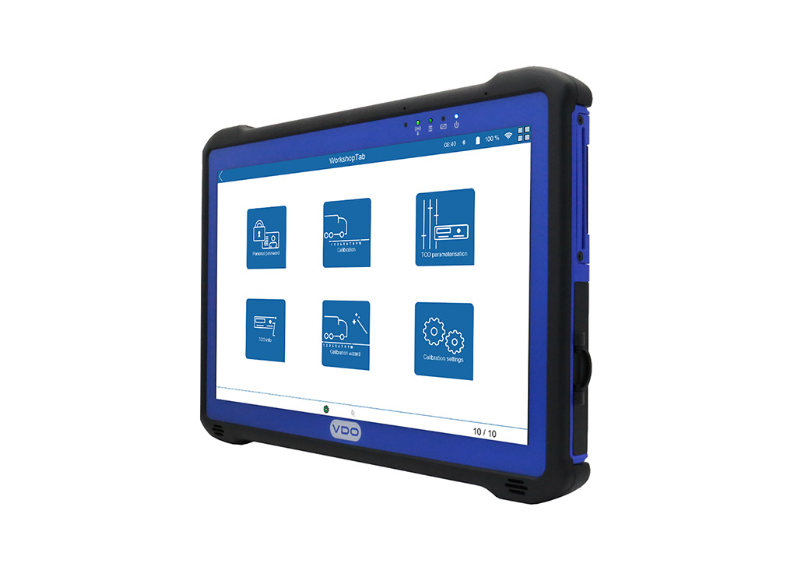 Continental_PP_VDO_  WorkshopTab2 | Ready for the future – the new VDO WorkshopTab 2 for comprehensive inspection and legally compliant calibration of digital tachographs.
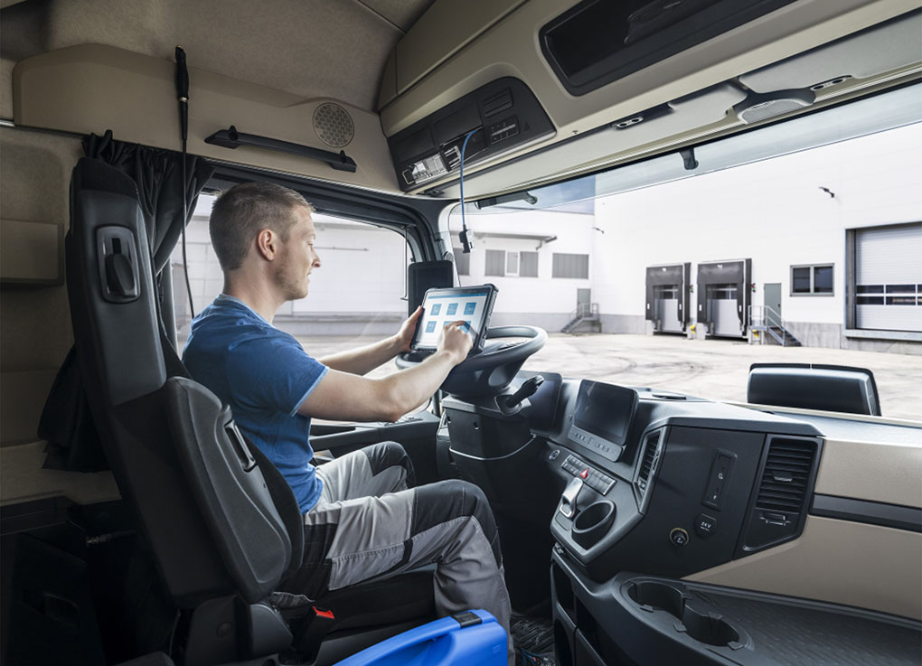  Continental_PP_  WorkshopTab2_cabin | The new VDO WorkshopTab 2 reliably guides the user through all of the inspection and maintenance routines for digital tachographs.

