IAA TRANSPORTATION 2022

Continental Trade Fair Highlight: Plug-and-Play Concept to Link Digital Tachographs with the Cloud
- VDO Link makes tachograph and vehicle data available remotely and in real time, thereby simplifying compliance tasks, especially for small fleets
- The talking tachograph feature helps drivers comply with legal requirements
- Sustainability, safe and fair transport, data-based services, connected vehicle: Continental presents comprehensive technology portfolio at IAA
Villingen-Schwenningen, Germany, August 11, 2022. At this year's IAA TRANSPORTATION, the technology company Continental will be presenting a broad portfolio of products, technologies and digital solutions relating to sustainability, connected commercial vehicles, data-based services as well as safe and fair transport. Under the motto “Mastering Challenges. Seizing Opportunities. Together.”, visitors to the Continental booth (Hall 12, Booth C29) can expect to see numerous innovations, including intelligent driver assistance systems and autonomous driving functions, all-round connected components, services for greater compliance, high-performance computing, and sustainable tires for the commercial vehicle sector. The most important leading trade fair for logistics, commercial vehicles, buses and the transport sector will take place in Hanover, Germany, from September 20 to 25.
One highlight will be a new solution for compliance in logistics: The VDO Link concept closes the gap between digital tachographs and online platforms for fleet management. The plug-and-play solution is the first of its kind, allowing tachograph data such as driving times and rest periods to be retrieved and processed in real-time from a distance – without the need for permanently installed telematics modules in the vehicle. “In particular, smaller fleets haven’t been able to make the most of their tachograph data because their vehicles often didn’t have the necessary telematics infrastructure,” explains Marcello Lucarelli, Head of the Connected Commercial Vehicle Solutions business segment at Continental. “VDO Link is an easy-to-use solution that closes this gap.”
Thanks to the open interface concept, more usage scenarios and services based on tachograph data can and will be developed in the future. VDO Link is yet another contribution by Continental to the digitalization of haulages and supply chains. “The technological advancement of the tachograph – that will reach a new level by mid-2023 with the release of the second version – means not only new tasks for companies in road transportation,” says Marcello Lucarelli. “Data from the tachograph nowadays give the opportunity to automate processes, simplify tasks and even to achieve productivity gains.”
Plug-and-play for more compliance
After plug-and-play installation and successful registration on the VDO Fleet Website, VDO Link sends the collected vehicle and driver data in real time to Continental’s Secure Cloud Backend using a secure mobile connection. The advantage for fleets: installation will be carried out without the need for a workshop visit. “Plug-and-play is always a good solution if you want to make a new service available as quickly as possible to many customers with different vehicle generations,” says Timo Ketterer, Head of Service Product Management in the Connected Commercial Vehicle Solutions business segment at Continental. Fleet managers will be able to take full advantage of Continental’s compliance services with this real-time connection to the cloud, which gives them an up-to-date overview of the fleet’s status and the current locations of individual vehicles. In addition, the mandatory download of the tachograph’s mass memory every ninety days will also work remotely via VDO Link in the future.
The talking tachograph communicates directly with the driver
One example for the added value coming from the combination of a plug-and-play telematics unit, a cloud backend and a digital service is the talking tachograph. Continental brought Augsburg-based start-up, ZeKju, on board as a partner in the development of this service. ZeKju had developed a platform to help drivers comply with their legal obligations, supported by real-time tachograph data, available in the cloud via VDO Link. When a driver has registered with the tachograph using his driver card, he can use his smartphone to register for the talking tachograph via a QR code. The driver will then receive a message on his preferred smartphone messenger when a situation arises where compliance is essential. For example, after crossing a border, a message can remind him to change the country code in the tachograph. Even the playback of short training videos is possible. “Almost all drivers have a smartphone, but they usually don’t want to download yet another app,” says Thorsten Stuke, co-founder of ZeKju. “We believe that the talking tachograph messages delivered to them on their preferred messenger channel will make their day-to-day lives much easier.” This is a considerable advantage for fleets with many international drivers because the talking tachograph can send messages in nineteen languages.
New services through partner integration
The collaboration with ZeKju is just one example of how Continental intends to continue expanding its portfolio of solutions for compliance in the transportation industry. By providing real-time data from the digital tachograph, VDO Link will offer many more possibilities to facilitate and optimize everyday fleet operations. For example, fleet managers could use the data on a vehicle’s current location, cargo space and weight to accept additional freight orders, increasing the fleet’s capacity utilization. The integration of toll services will also be possible in the future. Therefore, Continental has deliberately opened up its technology and cloud infrastructure for more partnerships. “Together with our development partners, clients and start-ups, we aim to unlock the full potential of the tachograph, constantly expanding the service landscape for fleets,” says Marcello Lucarelli.
At the IAA TRANSPORTATION, visitors to the Continental booth (Hall 12, Booth C29) will not only experience the Trailer Capacity Assessment, but also many other solutions for the major challenges of the mobile future in freight transport.
Continental develops pioneering technologies and services for sustainable and connected mobility of people and their goods. Founded in 1871, the technology company offers safe, efficient, intelligent and affordable solutions for vehicles, machines, traffic and transportation. In 2021, Continental generated sales of €33.8 billion and currently employs more than 190,000 people in 58 countries and markets. On October 8, 2021, the company celebrated its 150th anniversary.
Continental develops pioneering technologies to make commercial transport safer, more efficient and more connected. The company’s products and services deliver measurable impact for commercial vehicle manufacturers and the aftermarket. They benefit from a broad portfolio and from fully integrated systems. The portfolio includes tires, digital tire monitoring, fleet management, telematic solutions, Electronic Logging Devices (ELD) and tachographs, hoses, air springs, Electronic Control Units (ECU), displays, sensors, advanced driving assistance systems, as well as eHorizon maps and events and cloud-based services. In 2021, the share of Continental’s global sales for commercial vehicle products, systems and services was
3,4 billion.

Press contact

Oliver Heil
Manager Media Relations
Smart Mobility
Continental
Phone: +49 6196 87-2681
Email: oliver.heil@continental-corporation.com

Press portal: www.continental-press.com
Media center: www.continental.com/media-center
Website: www.fleet.vdo.com
Pictures and Captions
Continental_PP_Fleet_Manager_  Window.jpg | A clear view on the state of the fleet. With VDO Link, Continental will provide fleet managers with real-time data from the tachograph.
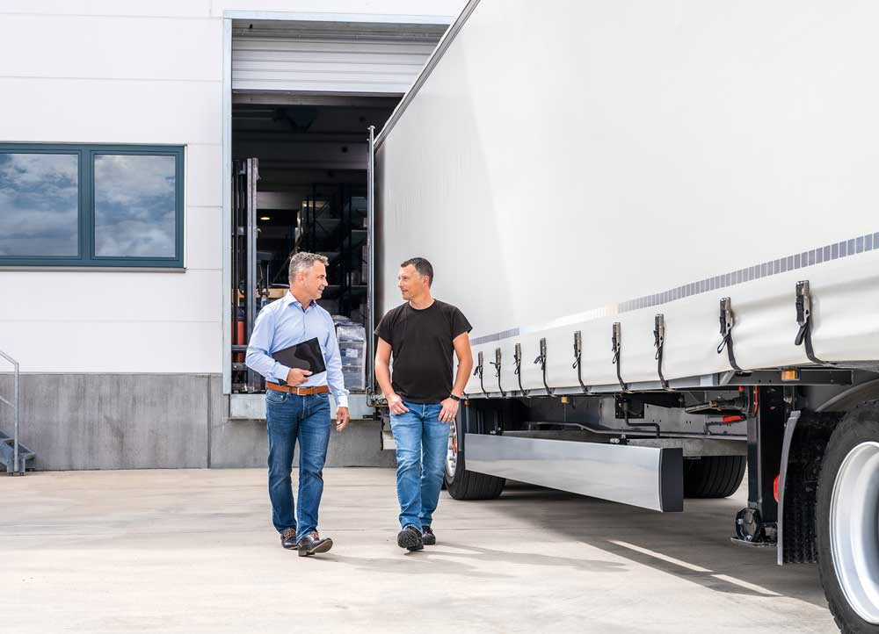  Continental_PP_Fleet_Manager_  Driver.jpg | Benefits for drivers and fleet managers: VDO Link supports the transmission of real-time data from the tachograph.

