

transport logistic

Ready for the DTCO 4.0: TIS-Web Continues to Comply With the Law and Is Even Smarter

* With the new software version TIS-Web DMM 5.0, fleet managers can also meet their legal storage and archiving obligations when using the new intelligent tachograph
* Fully reworked user interface and responsive design provide a better fleet overview
* Numerous analytical functions announced as updates
* TIS-Web Motion: Continuous, up-to-date data on the condition and location of all vehicles

Munich/Villingen-Schwenningen, June 4th 2019. The introduction of the intelligent digital tachograph also has repercussions for fleet management. To ensure that fleet operators can continue to meet their legal obligations relating to data archiving, the technology company Continental has developed a new version of its VDO TIS-Web fleet management system. The software can be ordered with immediate effect. Among other things, the new generation of software is required due to the modified encryption technology in the intelligent tachograph. However, Continental has done far more than simply implement the necessary updates: Many further innovations make fleet management with TIS-Web DMM 5.0 even more convenient and efficient. “With the new version, we wanted to achieve three things,” explains Marcello Lucarelli, Head of the Business Segment Tachographs, Telematics and Services at Continental. “The certainty for our customers that they comply with legal requirements, an intuitive user interface, and more fleet management functions so that smaller and mid-sized fleets can benefit from the advantages of fleet analysis without any entry-level barriers.”

Meeting legal requirements

The TIS-Web online software consists of individual services, which fleet managers can add and deselect according to requirements. Anyone who uses the Data Management (DMM) core service for the legally compliant read-out, archiving and storage of driver and vehicle data should not delay in migrating from DMM version 4.9. to DMM version 5.0 as soon as the fleet includes a vehicle that has the DTCO 4.0 on board.

Because the intelligent tachograph demands wide-ranging technical changes at all levels, Continental has reprogrammed the VDO TIS-Web system to create a reliable basis for the future. However, this upgrade is not possible by means of simple updates and existing TIS-Web customers will have to switch to TIS-Web DMM 5.0. They can expect to be contacted by Continental or a dealer. Further information can be found at <https://www.fleet.vdo.com/><https://www.fleet.vdo.de/>

Optimum fleet coordinate system: new fleet analysis functions

However, TIS-Web DMM 5.0 can do much more: Thanks to a wealth of clearly prepared data on drivers, vehicles, driving behavior and tachographs, fleet managers can administer their fleets even more simply and efficiently. They can see vehicles and drivers, driving and rest periods, as well as any infringements, at a glance. The driver’s remaining driving time is also output. The reminder functions for download due dates, card expiry dates, driving license verifications, maintenance or calibration dates and the graphically presented, interactive driver and vehicle activity summaries are also extremely practical. The system also warns fleet managers of possible infringements that could lead to penalties. “Currently more than 250,000 vehicles and 500,000 drivers are being managed with TIS-Web. TIS-Web is available throughout Europe, in every language, with distribution points in each country and technical support in the local language,” says Diego Santos-Burgoa, Head of Sales in the Tachographs, Telematics and Services Business Segment at Continental.

The developers of TIS-Web DMM 5.0 are already planning the next steps: With the forthcoming updates, they will gradually add what will ultimately be an extensive range of analyses to TIS-Web DMM – with a wide choice of statistics and reports, for example on speeds and rpm profiles.

Clear and intuitive: the new dashboard

Continental has completely redesigned the user interface for TIS-Web DMM 5.0. In the dashboard, fleet managers can see at a glance all the information that is important for their work and they can also configure the interface to meet their specific needs. The enhanced clarity and more easily understandable displays simplify day-to-day work and speed up loading times compared to the previous version. Thanks to the responsive design, fleet managers can use TIS-Web on their desktop or on a tablet or smartphone.

Perfect partners: TIS-Web DMM and TIS-Web Motion

The same applies for the latest version of the TIS-Web Motion service. It provides fleet managers with an uncomplicated, intuitive, economical software solution for the more efficient control of their fleets on the basis of up-to-date location data and movement patterns. TIS-Web Motion is therefore the perfect complement to the capabilities offered by the DMM service. For example, with the geofencing feature: If the vehicle travels beyond a point previously defined on the map then a notification automatically appears in the dashboard. This enables trucking companies to inform their customers of the arrival of deliveries to an accuracy of a matter of minutes. This speeds up loading and unloading processes and minimizes vehicle idle times.

A further addition for efficient fleet management is the TIS-Web Data Services. TIS-Web Connect is an intelligent interface that enables tachograph data to be automatically transferred from various fleet management systems to TIS-Web. For data transfer in the other direction, there is TIS-Web Extract, which integrates selected data from TIS-Web into company-specific software solutions such as accounting systems.

Continental develops pioneering technologies and services for sustainable and connected mobility of people and their goods. Founded in 1871, the technology company offers safe, efficient, intelligent, and affordable solutions for vehicles, machines, traffic and transportation. In 2018, Continental generated sales of €44.4 billion and currently employs around 245,000people in 60 countries and markets.

Information management in and beyond the vehicle is at the very heart of the Interior division. The product portfolio for different types of vehicles includes: instrument clusters, multifunctional and head-up displays, control units, access control and tire-information systems, radios, infotainment systems, input devices, control panels, climate control units, software, cockpits as well as services and solutions for telematics and Intelligent Transportation Systems. The Interior division employs around 48,000 people worldwide and generated sales of €9.7 billion in 2018.

Press contact

Oliver Heil

Manager Media Relations

Commercial Vehicles & Aftermarket

Phone: +49 69 7603-9406

E-mail: oliver.heil@continental-corporation.com

**Press portal:** www.continental-press.com

**Media center:** www.continental.com/media-center

Pictures and picture captions

|  |  |
| --- | --- |
| Continental_VDO_PP_TTS_Visual_05.jpg | Fast, clear and ready for DTCO 4.0: The new version of Continental’s VDO TIS-Web fleet management system is here. |
| Continental_VDO_PP_TTS_Visual_02.jpg | With the new version, VDO TIS-Web DMM 5.0, fleet managers can also meet their legal storage and archiving obligations when using the intelligent digital tachograph. |
| Continental_VDO_PP_TTS_Visual_01.jpg | With numerous statistics and reports, the VDO TIS-Web fleet management solution will permit detailed analyses in the future. |
|  |  |

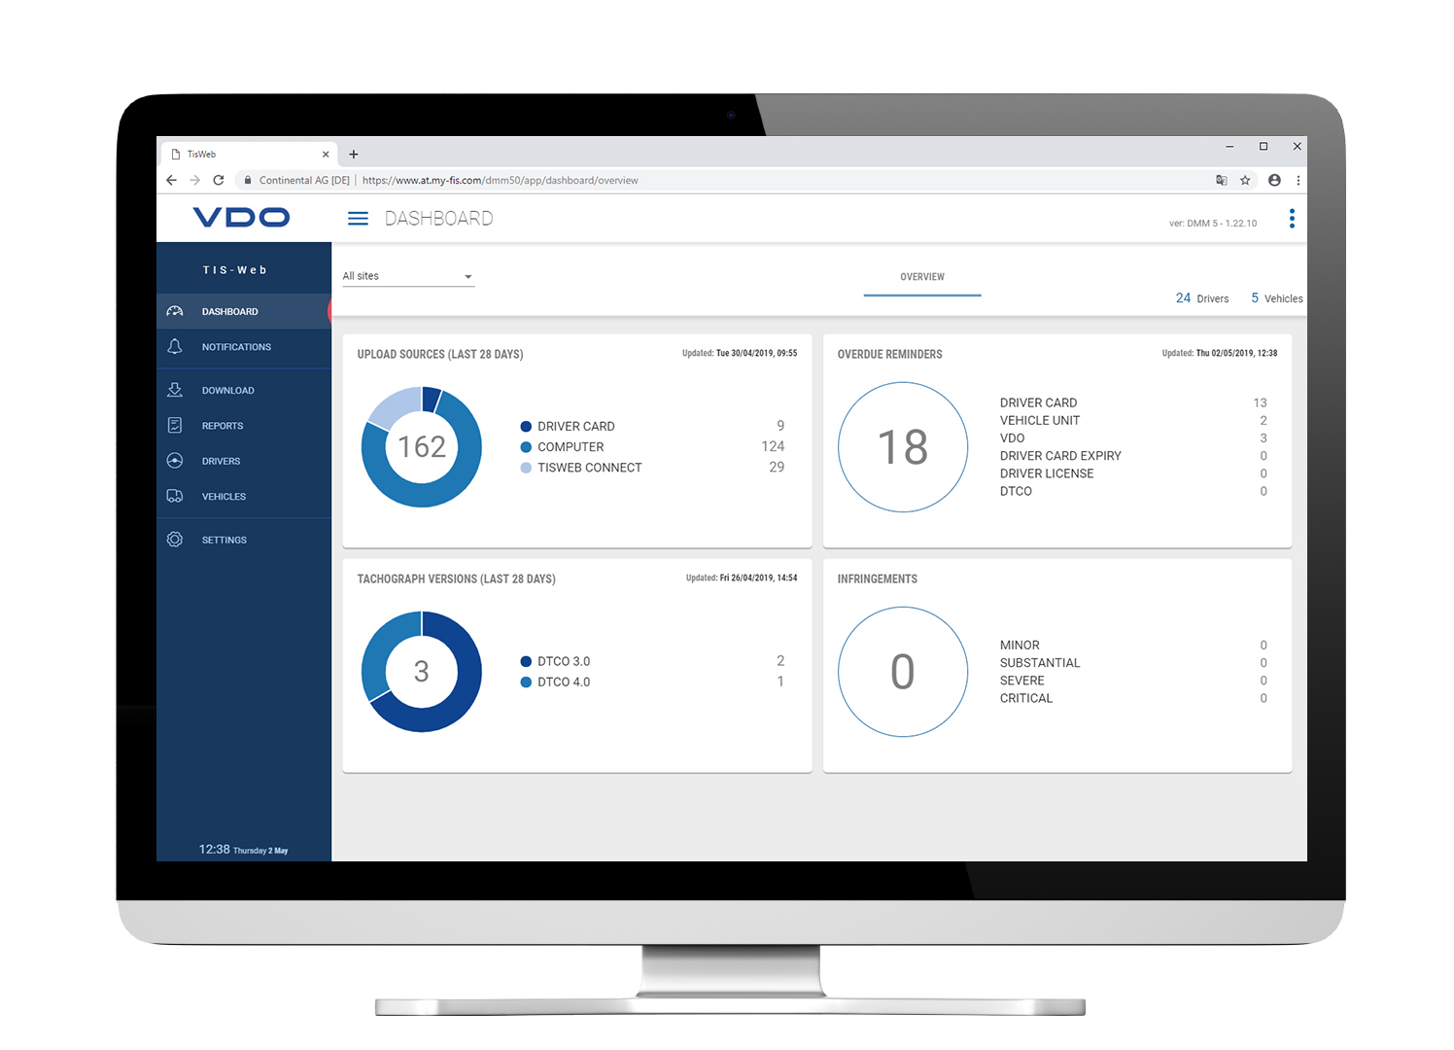

Continental_VDO_PP_TTS_

Dashboard.jpg

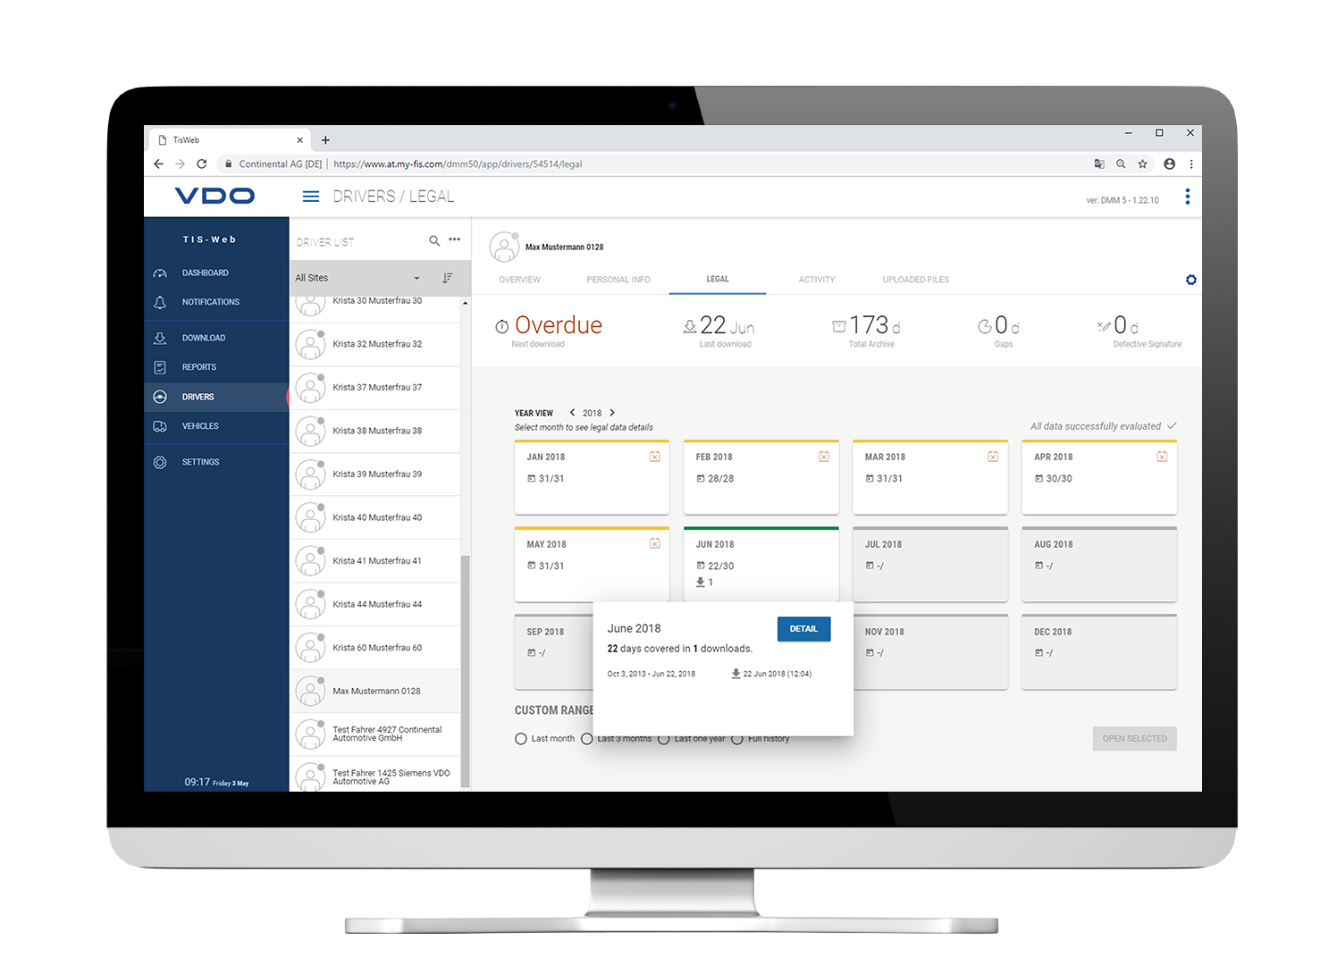

Continental_VDO_PP_TTS_

Drivers.jpg