Continental Supplies Tachograph Data Management Solution for Frotcom´s Fleet Management System
- More insights, more efficiency: Continental’s VDO TIS-Web solution for tachograph data management has been interfaced with Frotcom FMS
- TIS-Web facilitates tachograph data management and provides insightful analyses
- Fleet managers benefit from more efficient data management and ways to optimize their operations
Villingen-Schwenningen, Germany, May 2021. Technology company Continental is supplying Frotcom, a global provider of intelligent fleet management systems, with its tachograph data management solution, VDO TIS-Web. To this end, Frotcom is able to offer their customers, via API, Continental’s data management software VDO TIS-Web into its own fleet management system. This facilitates storing, accessing and analysing data from smart tachographs and ultimately helps fleet companies maximise their efficiency.
Intelligent tachograph data management with TIS-Web
Specifically designed to help fleet managers store tachograph data, VDO TIS-Web is the ideal solution to ensure fleets comply with European legal requirements for archiving vehicle and driver data. Fleet managers can simply link their Frotcom account to their TIS-Web account.
Tachograph data downloaded by Frotcom’s fleet management system will then automatically be sent to TIS-Web. The software analyses the data in terms of drivers, vehicles, driving styles and more, providing fleet managers with reports that effectively optimize their operations. It’s also possible to tailor the TIS-Web data analyses to factor in specific local or national regulations so that users only receive information relevant to their respective businesses or countries of operation. Another benefit is that, given TIS-Web is a cloud-based solution, fleet managers can access it from anywhere, even via a smartphone app.
Continental-Frotcom-partnership benefits fleet companies
In an increasingly competitive environment, the partnership between Continental and Frotcom aims to help fleets of all industries boost efficiency and remain fit for the future. It will also strengthen both companies’ position as leading providers of fleet and data management solutions.
“At Continental, we are always looking for promising areas of growth. Frotcom is an ever-growing international company with a multitude of customers – the partnerships bring us new possibilities and allows us to tap into new customer groups. We’re very pleased that we can now offer our services to those businesses that are looking for more comprehensive fleet management solutions,” explains Marcello Lucarelli, head EMEA Business Segment Commercial Vehicle Fleet Services at Continental.
Adds Clive Taylor, Commercial Director at Frotcom International: “Helping our customer’s improve their safety, cost efficiency and customer satisfaction are our three major goals. In this sense, VDO TIS-Web is the ideal addition to our fleet management system as it helps us give our customers peace of mind. It’s an intuitive and adaptable solution that makes tachograph data archiving and analyses even simpler and helps our customers all across Europe to achieve 100 percent compliance with regulations.”
Further information about the integration of TIS-Web into Frotcom is available here: https://www.frotcom.com/features/integration-tis-webr

Continental develops pioneering technologies and services for sustainable and connected mobility of people and their goods. Founded in 1871, the technology company offers safe, efficient, intelligent and affordable solutions for vehicles, machines, traffic and transportation. In 2020, Continental generated sales of €37.7 billion and currently employs around 235,000 people in 58 countries and markets. In 2021, the company celebrates its 150th anniversary.
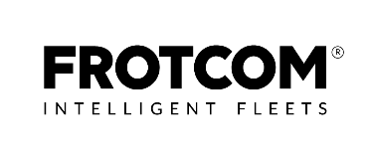
Continental develops pioneering technologies to make commercial transport safer, more efficient and more connected. The company’s products and services deliver measurable impact for commercial vehicle manufacturers and the aftermarket. They benefit from a broad portfolio and from fully integrated systems. The portfolio includes tires, digital tire monitoring, fleet management, telematic solutions, Electronic Logging Devices (ELD) and tachographs, hoses, air springs, Electronic Control Units (ECU), displays, drivetrain and exhaust aftertreatment systems, sensors, advanced driving assistance systems, as well as eHorizon maps and events and cloud based services. In 2019, the share of Continental’s global sales for commercial vehicle products, systems and services was 5 billion.

Frotcom is currently present in more than 40 countries worldwide through a network of local Frotcom Certified Partners. Frotcom is used by thousands of companies worldwide for fleet management and GPS vehicle tracking. The solution has been adopted by both small and large fleets with more than one thousand vehicles. See more at: www.frotcom.com

Press contact

Continental
Oliver Heil
Manager Media Relations
Commercial Vehicles & Services
Continental Aftermarket & Services GmbH
Phone: +49 6196 87-2681
Email: oliver.heil@continental.com

Frotcom
Gisela Batalha
Communications Director
Frotcom International
Phone: +351 214 135 670
Email: marketing@frotcom.com

Press portal www.continental-press.com
Media center www.continental.com/media-center
VDO Website www.fleet.vdo.com
Frotcom Website www.frotcom.com
Social Media www.linkedin.com/company/vdo-deutschland

pictures/captions
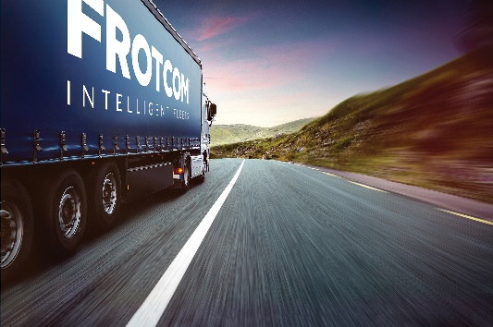  Continental_PP_Data_Management | Continental’s and Frotcom’s combined fleet management solution facilitates tachograph data management.  Copyright: Frotcom
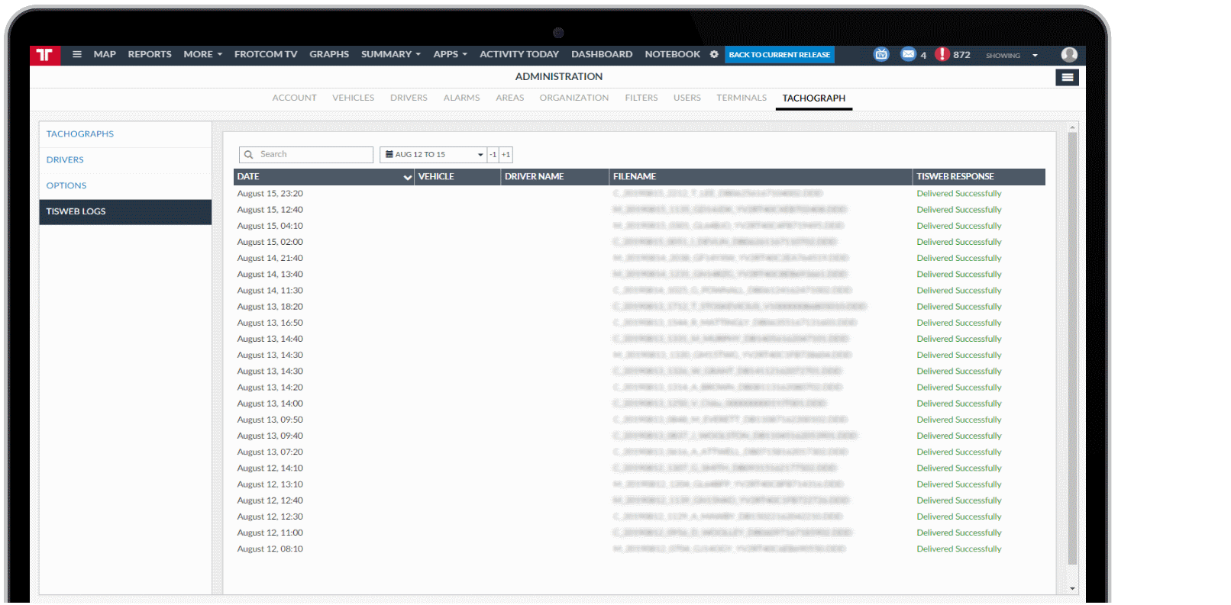  Continental_PP_TISWeb_Frotcom | TIS-Web logs view in Frotcom.  Copyright: Frotcom
Continental_PP_VDO_Fleet_  Management | VDO TIS-WEB is an intelligent data management software module for archiving tachograph data and meet EU requirements.
Continental_PP_VDO_TIS-Web | TIS-Web analyses tachograph data and provides fleet managers with valuable insights to help increase efficiency.

