Setting the course for the Trust Center for commercial vehicles – the DTCO 4.1 is en route!
- The tachograph will have completely new control functions in the future, in line with the EU directives on cabotage and the posting of workers
- The new tachograph will be mandatory in all newly registered commercial vehicles from August 21, 2023
Villingen-Schwenningen, Germany, September 1, 2021. Continental has started work on the second-generation intelligent tachograph. With the publication of the specifications for the upcoming version of the digital tachograph, the team of hardware and software engineers and the legal, logistics and policy experts headquartered in Villingen-Schwenningen in the Black Forest has entered the next phase of development and industrial engineering.
“We have already undertaken extensive preparatory work in recent months – in parallel with work on the current DTCO 4.0e upgrade, in which we have primarily improved handling and speed,” reports Dirk Gandras, program manager responsible for tachographs in Continental’s Commercial Vehicle Fleet Services business segment. “Now we’re delighted that we have all the necessary information on the table and can finally get started. We will do our utmost to map the often complicated political regulations in our tachograph in such a way that everything is understandable and can be operated without worry. We’re also aiming to deliver the new generation as early as we did with the current DTCO 4.0 generation.” Two years after the Implementing Regulation EU 2021/1228 becomes effective, i.e. from August 21, 2023, all newly registered commercial vehicles with a gross vehicle weight of more than 3.5 tonnes must be equipped with the second-generation intelligent tachograph.
The next step in the evolution of the tachograph – cabotage and the posting of workers
Continental says this will strengthen the importance of the DTCO as an instrument for achieving goals in social policy and transport policy. “In its efforts to ensure fairer competition on European roads, we’re delighted that the European Commission is supporting the tachograph,” says Matthias Kliché, Head of Legal Requirements in Continental’s Commercial Vehicle Fleet Services business segment. “For the first time in its almost century-long history, this gives the tachograph a control function that goes beyond the recording of work and operating times.”
Continental’s next-generation intelligent tachograph will enable the implementation of the key directives set out in Mobility Package I. Most important among these are the rules governing cabotage and the posting of workers in the transport industry. The tachographs installed in commercial vehicles will also reliably record border crossings in the future via a satellite positioning system. The tachograph program will then be the world’s first application to use the freely available Galileo service to authenticate the navigation signal. The previously optional ITS interface will become mandatory in the form of a Bluetooth interface, and this will make many more usage scenarios possible in the future, in addition to the control of cabotage. The tachograph can transform data into trustworthy, secure, and uniquely attributable data. This will create opportunities that go far beyond policy controls, such as microservices that will make the jobs of commercial vehicle fleet operators and many of their service providers much easier.
Background
The topic is not new, but it has become increasingly urgent in recent years: the cabotage and posting of professional truck drivers. The EU’s Mobility Package I is aimed at ensuring fair competition in the European domestic market – and the DTCO 4.1 will play a key role in the implementation of the legal requirements since it will use satellite positioning and integrated maps to record border crossings. In this way, it will enable the authorities to monitor the applicable regulations more efficiently, since in case of doubt they will be able to see how many trips both vehicle and driver have made and when and in which countries these trips took place.
Timeline for the introduction of the second generation intelligent tachograph
› August 2023: All newly registered vehicles with a maximum permissible weight of more than 3,5 tons must be equipped with the 2nd generation intelligent tachograph.
› End of 2024: In all vehicles with a maximum permissible weight of more than 3,5 tons the old analog or digital tachographs must be replaced, if the vehicles are used in cross-border traffic. The intelligent tachograph of the first generation is excluded.
› September 2025: Vehicles with a maximum permissible weight of more than 3,5 tons equipped with the 1st generation intelligent tachograph must be upgraded. This only applies, if the vehicles are engaged in cross-border traffic.
› July 2026: Commercial vehicles with a maximum permissible weight between 2.5 tons and 3.5 tons must be equipped with the 2nd generation intelligent tachograph. This only applies, if the vehicles are engaged in cross-border traffic.
Continental develops pioneering technologies and services for sustainable and connected mobility of people and their goods. Founded in 1871, the technology company offers safe, efficient, intelligent, and affordable solutions for vehicles, machines, traffic and transportation. In 2020, Continental generated sales of €37.7 billion and currently employs around 233,000 people in 58 countries and markets. In 2021, the company celebrates its 150th anniversary.
Continental develops pioneering technologies to make commercial transport safer, more efficient and more connected. The company’s products and services deliver measurable impact for commercial vehicle manufacturers and the aftermarket. They benefit from a broad portfolio and from fully integrated systems. The portfolio includes tires, digital tire monitoring, fleet management, telematic solutions, Electronic Logging Devices (ELD) and tachographs, hoses, air springs, Electronic Control Units (ECU), displays, drivetrain and exhaust aftertreatment systems, sensors, advanced driving assistance systems, as well as eHorizon maps and events and cloud based services. In 2019, the share of Continental’s global sales for commercial vehicle products and systems was around €5 billion.
Press contact

Oliver Heil
Manager Media Relations
Commercial Vehicles & Services
Continental
Phone: +49 6196 87-2861
Email : oliver.heil@continental.com

Press portal: www.continental-press.com
Media center: www.continental.com/media-center
VDO Website: www.fleet.vdo.com

Pictures/captions
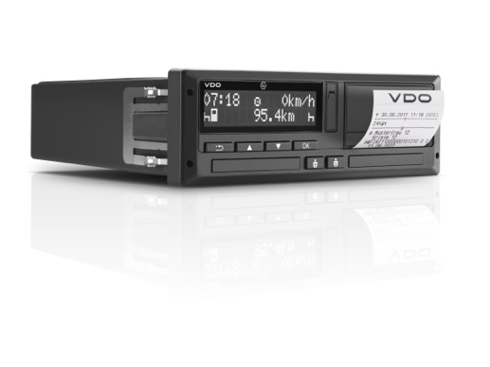  Continental_VDO_PP_DTCO | Continental sees the tachograph as an important instrument for achieving social and transport policy goals.
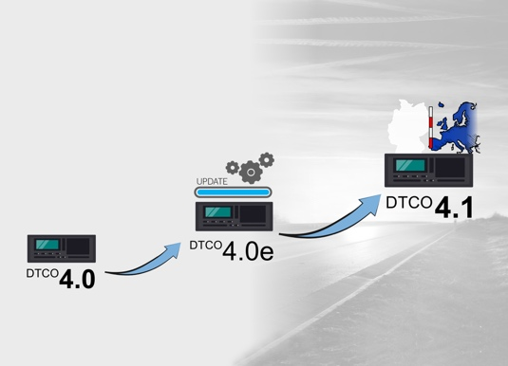  Continental_VDO_PP_DTCO_  Evolution | The evolution of the intelligent tachograph now continues with the second generation, which will be mandatory in new vehicles from 2023.
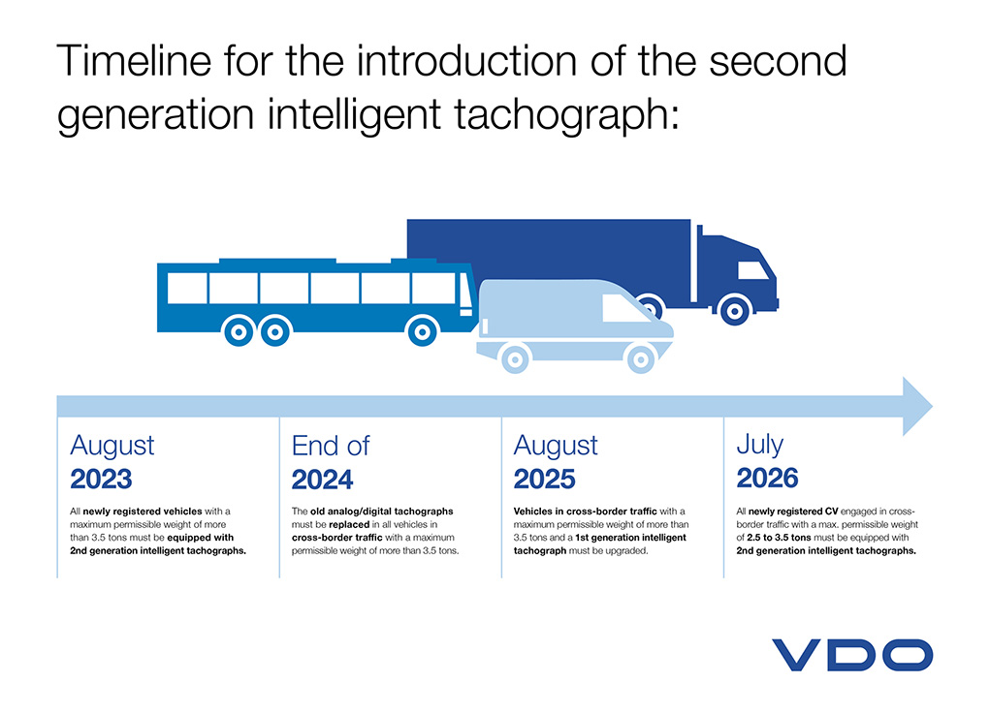  Continental_VDO_PP_DTCO_  Timeline | From August 21, 2023, the new tachograph will be mandatory in all newly registered commercial vehicles; further development steps will follow in the next few years.

