The European Register of Road Transport Undertakings (ERRU)
- The European Commission plans to set up a European Register of Road Transport Undertakings – ERRU for short
- The aim of the Register is to allow a better exchange of information between Member States about compliance infringements
Function of the ERRU
In order to be able to monitor and effectively sanction compliance of transport companies, the European Commission began pushing for the establishment of a central register in 2013 – the European Register of Road Transport Undertakings (ERRU).
The ERRU is intended to fulfill three central functions. First of all, infringements of the rules in force or the relevant standards for transport companies can be reported. The Member State in which such an infringement has been committed must notify the Member State in which the road transport undertaking is established that it has committed a serious infringement. The Member State in which an infringement has been committed may request that sanctions be imposed on the road transport undertaking in the Member State in which it is established.
A Member State may also send a request to one or all Member States to determine the fitness of a transport manager and thus his or her authorization to manage a road transport undertaking.
Any Member State can also send a request to all other Member States to determine whether a road transport undertaking has a valid Community license.
Penalty points and sanctions
Infringements can not only be reported and viewed in the ERRU. They also attract penalty points. If a defined points limit is exceeded, the undertaking's reliability status is jeopardized and a procedure is started. This procedure may result in the loss of the transport manager's suitability status and the approved status of the undertaking. This would result in the loss of the undertaking's transport license.
The level of the limit value is determined by the number of certified transport license copies that an undertaking holds. For the transport manager who works for several undertakings, the number of licenses of all the different undertakings are added together to determine the penalty point limit value.
The penalty points are then based on the seriousness of the infringements and are allocated according to a ratio laid down in the Regulation. The most serious category of violations (MSI = Most Serious Infringements) attracts nine penalty points, the middle category (VSI = Very Serious Infringements) three and the lowest category (SI = Serious Infringements) one penalty point.
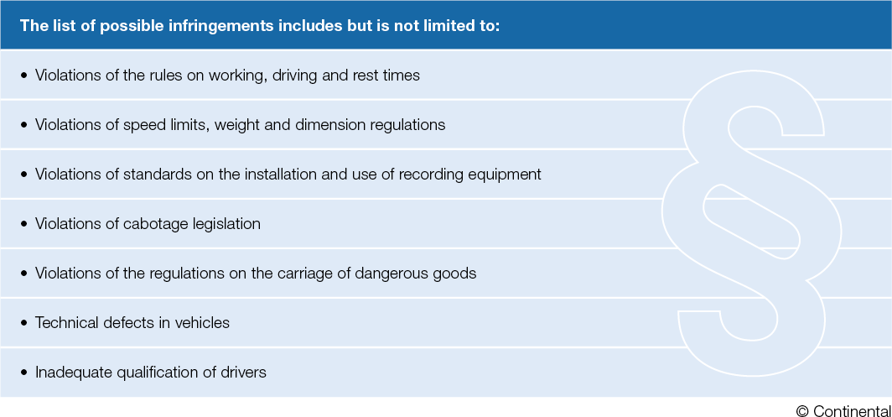
The data in the ERRU
The data in the ERRU originates from the national electronic registers. These registers contain at least the following data:
1. Name and legal form of the undertaking;
2. Address of the branch;
3. Name of the transport manager;
4. Type of license, number of vehicles covered and, where applicable, serial number of the Community license and of the certified copies;
5. Number, category and type of serious infringements that have resulted in a conviction or a sanction in the previous two years;
6. Names of persons declared unfit to manage the transport activities of an undertaking until the good repute of the person concerned has been restored, plus relevant rehabilitation measures.
While the data from 1 to 4 can be viewed publicly, the information from 5 and 6 is only accessible to the competent authorities under strict conditions. The data relating to an undertaking whose license has been suspended or withdrawn shall remain in the national electronic register for two years after the expiry of the suspension or withdrawal.
The data relating to a person declared unfit to engage in the occupation of road transport operator shall remain in the national electronic register as long as the good repute of that person has not been restored. The data will only be deleted after the rehabilitation measures have been carried out.
Continental has created a White Paper on ERRU that offers even more information on the subject. It can be downloaded here: https://www.fleet.vdo.com/white-paper-scorecards/

We look forward to feedback or questions
Oliver Heil
Manager Media Relations
Smart Mobility (SMY)
Continental
Phone: +49 69 7603-9406
Email: oliver.heil@continental-corporation.com

Press portal www.continental-press.com
Media center www.continental.com/media-center
Product information www.flet.vdo.com

